Login Paper-Based Prototypes

Below can be found the two prototypes for the login process. The first one is a fairly standard, vertically structured, layout with each component placed one on top of the other, while the second is more horizontally based, with each step that the user has to complete being on a different layer.

With no theme yet selected, this will work as a schema that can later be applied to a generic theme.

# Prototype One

Main Login Page

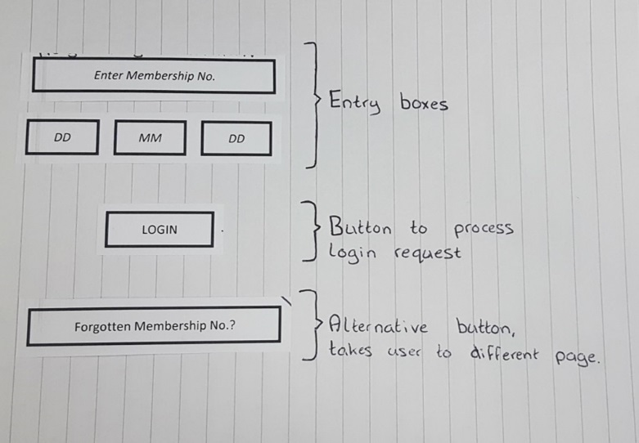

Forgotten Membership Number Page

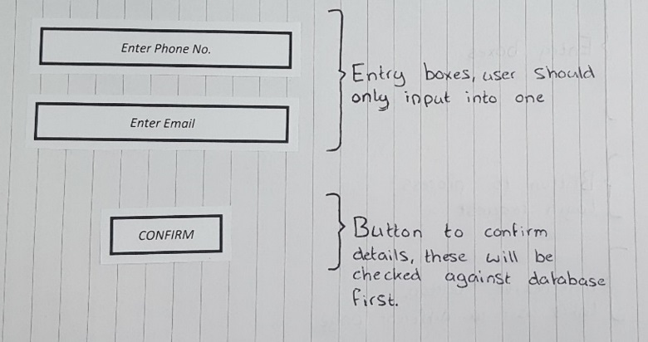

Confirmation Page

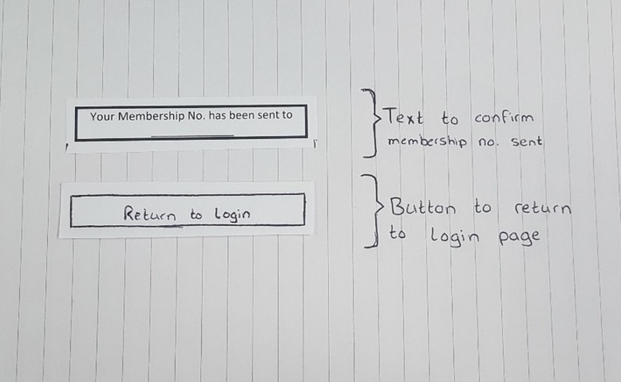

# Prototype Two

Main Login Page

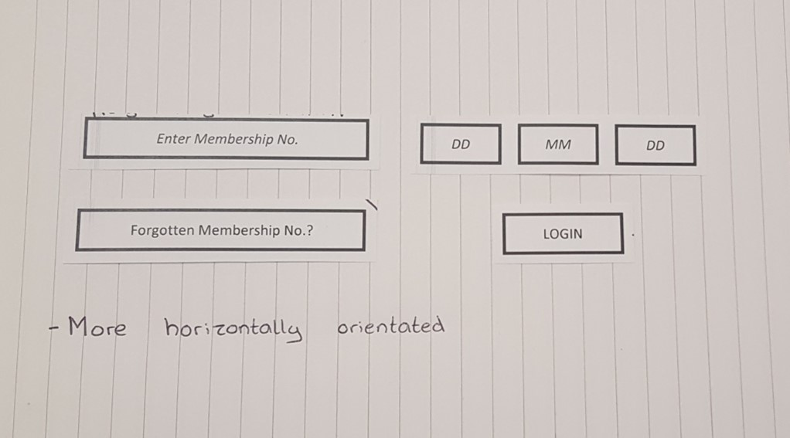

Forgotten Membership Number Page

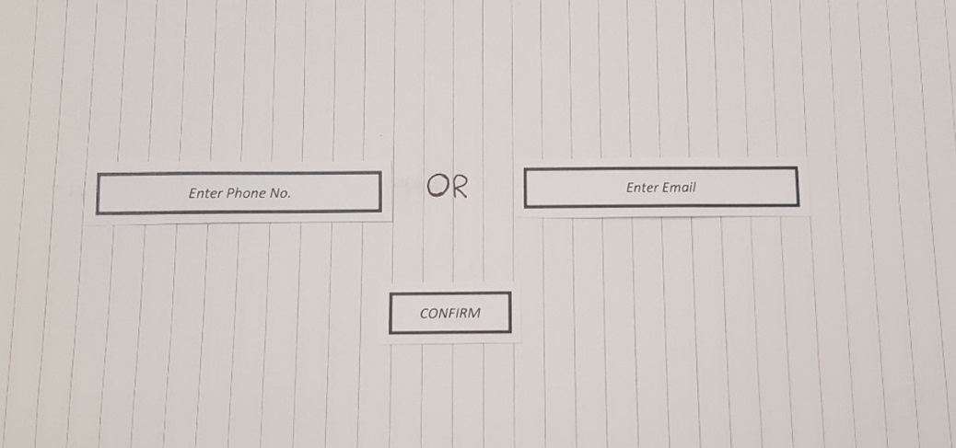

Confirmation Page

